# Gregory Prosper COP 4331

## Problem 2.1 (a)

Log in (Edited)

1. The mailbox owner carries out **Reach an Extension**.
2. The mailbox owner types the passcode, followed by the # key. (The default pass- code is the same as the mailbox number. The mailbox owner can change it—see **Change the Passcode**.)
3. The voice mail system plays the mailbox menu:  
   *Enter 1 to retrieve your messages.*  
   *Enter 2 to change your passcode.   
   Enter 3 to change your greeting.*   
   *Enter 4 to delete all messages from a phone number*

Delete a Message

1. The mailbox owner carries out **Log in**
2. The mailbox owner selects the “Delete all messages from a phone number” menu option.
3. The voice mail system speaks a prompt.

*Enter the phone number to delete all messages*

1. The user types the phone number, followed by the # key.
2. All messages from specified phone number are deleted.
3. Continue to step 3 of **Log in**

Variation #1 Number Not Found

* 1. Start at step 4.
  2. The voice mail system speaks a prompt.

*The phone number you entered was not found*

1.3. Continue to step 3 of **Log in**

## Problem 2.1 (b)

Normal Case:

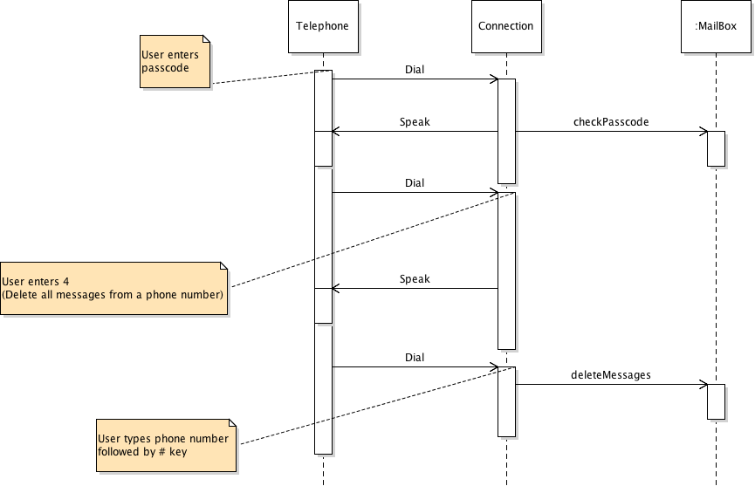

Variation #1:

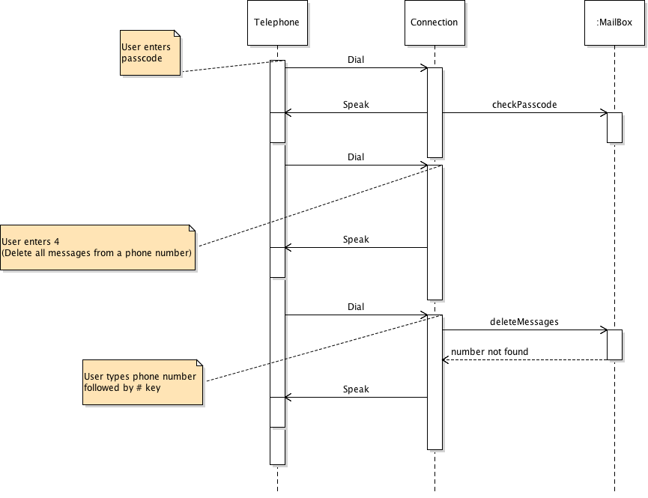

## Problem 2.2

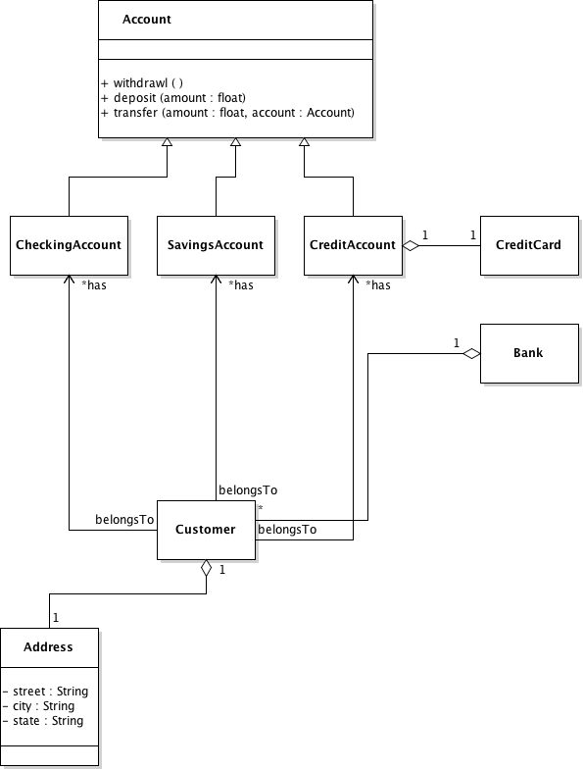

## Problem 2.3

CRC Cards

**Customer**

* Store Customer info

**System :** Collaborates with **Rental Company**

* Manages Rental Companies
* Manages Reservations

**Rental Company :** Collaborates with **Car**

* Manages Cars

**Reservation**

* Store Reservation Info

**Car**

* Store Car Info

UML Class Diagram

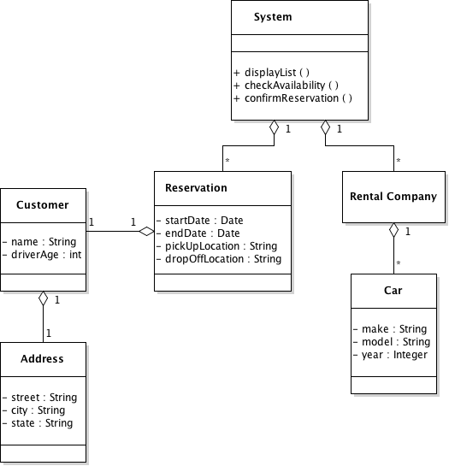

Sequence Diagram

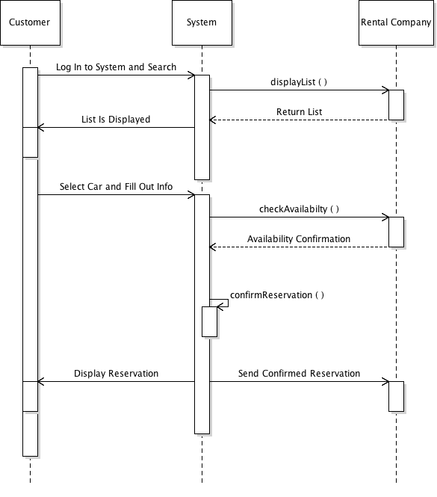

State Diagram

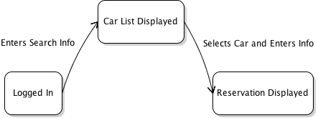

## Problem 2.4

**Inventory** Collaborates with **Product**

* Manages list of products

**Product**

* Contains product info

**Register** Collaborates with **Inventory**

* Manages list of purchased products
* Responsible for scanning products

Class Diagram

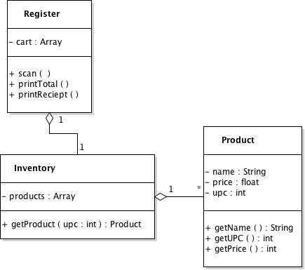

Sequence Diagram

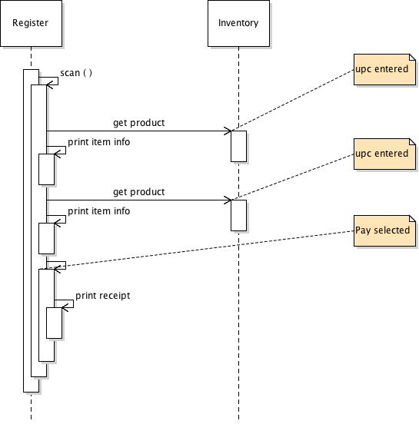

State Diagram

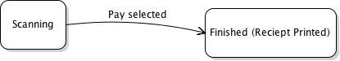

Code

------------------------------------------------------------------------------------------------------------

### Product.java

**package** register;

/**

* A class for the Product object.

* */

**public** **class** Product {

/**

* Constructs a Product object from the given parameters.

* **@param** name the name of the product.

* **@param** price the price of the product.

* **@param** upc the UPC number of the product.

* */

**public** Product(String name, **float** price, **int** upc){

**this**.name = name;

**this**.price = price;

**this**.upc = upc;

}

/**

* Retrieves the name of the product.

* **@return** the name of the product.

* */

**public** String getName (){

**return** **this**.name;

}

/**

* Retrieves the price of the product.

* **@return** the price of the product.

* */

**public** **float** getPrice (){

**return** **this**.price;

}

/**

* Retrieves the UPC number of the product.

* **@return** the UPC number of the product.

* */

**public** **int** getUPC (){

**return** **this**.upc;

}

**private** String name;

**private** **float** price;

**private** **int** upc;

}

### Inventory.java

**package** register;

**import** java.util.ArrayList;

/**

* A class for the Inventory object.

* */

**public** **class** Inventory {

/**

* Constructs a Inventory object.

* */

**public** Inventory (){

String[] names = {"Bread","Cookies","Pantry","Couch","T-Shirt","Tv","Hammer","Shoes","Drawer","Basket","Belt"

,"Toothbrush","Radio","Lotion","Slippers","Curtains"};

**float**[] prices = {(**float**) 2.34,(**float**) 1.12,(**float**) 13.23,(**float**) 532,(**float**) 5.99,(**float**) 1200,(**float**) 17.78,(**float**) 34.99,(**float**) 32.89,(**float**) 2.12,(**float**) 3.45,(**float**) 7.99,(**float**) 133,(**float**) 3.55,(**float**) 13.44,(**float**) 198.10};

//Creates products and adds them to products ArrayList

**for** (**int** i = 0; i < prices.length; i++) {

Product p = **new** Product(names[i],prices[i],i+100);

**this**.products.add(p);

}

}

/**

* Retrieves a product from the Inventory by UPC number.

* **@param** upc the UPC number of the product to be searched for.

* **@return** a product from the inventory with the matching UPC number.

* */

**public** Product getProduct (**int** upc){

**for** (Product p : **this**.products) {

**if** (p.getUPC() == upc) {

**return** p;

}

}

Product p = **new** Product("",0,0);

**return** p;

}

**private** ArrayList<Product> products = **new** ArrayList<>();

}

### Register.java

**package** register;

**import** java.util.ArrayList;

**import** java.util.Scanner;

/**

* A class for the Register object.

* */

**public** **class** Register {

/**

* Constructs a Register object.

* */

**public** Register (){

System.*out*.print("Register Initialized. Enter UPC numbers or Enter 'pay' to complete transaction\n");

}

/**

* Scans for UPC numbers until user inputs 'pay'.

* */

**public** **void** scan (){

Scanner in = **new** Scanner(System.*in*);

**while** (in.hasNext()) {

**if** (in.hasNextInt()) {

**int** upc = in.nextInt();

**if** (upc >= 100 && upc <= 115) {

**this**.cart.add(**this**.inventory.getProduct(upc));

}

**else** {

System.*out*.print("Invalid UPC number, must be within 100 - 115 \n");

}

}

**else** **if** (in.next().equalsIgnoreCase("pay")) {

**this**.printReciept();

**break**;

}

**else**{

System.*out*.print("Invalid Input. Enter UPC number or 'pay'.\n");

}

}

in.close();

}

/**

* Prints the total to the console.

* */

**public** **void** printTotal (){

**float** total = 0;

**for** (Product p : **this**.cart) {

total += p.getPrice();

}

System.*out*.printf("\nTotal: $%.2f", total);

}

/**

* Prints Every item in cart to console then prints total to console.

* */

**public** **void** printReciept (){

System.*out*.print("Reciept:\n");

System.*out*.printf("%3s %15s %10s\n","UPC","Item","Price");

**if** (**this**.cart.isEmpty()) {

System.*out*.print("(No Items in Cart)");

}

**else** {

**for** (Product p : **this**.cart) {

System.*out*.printf("%3d %15s %10.2f \n", p.getUPC(),p.getName(),p.getPrice());

}

}

**this**.printTotal();

}

**private** ArrayList<Product> cart = **new** ArrayList<>();

**private** Inventory inventory = **new** Inventory();

}

### RegisterTester.java

**package** register;

/**

* A class to test Register class.

* */

**public** **class** RegisterTester {

/**

* Main class.

* **@param** args

*/

**public** **static** **void** main(String[] args) {

Register register = **new** Register();

register.scan();

}

}